**Problem No. 2**

**Number of sales each day of 2014:**

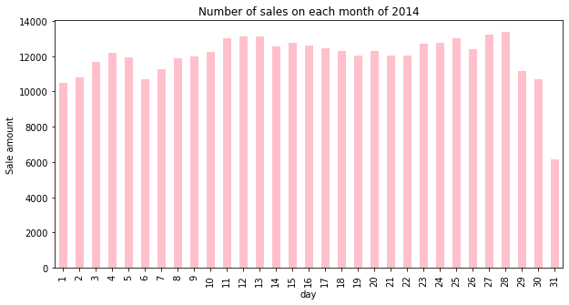

**Number of sales each day of 2015:**

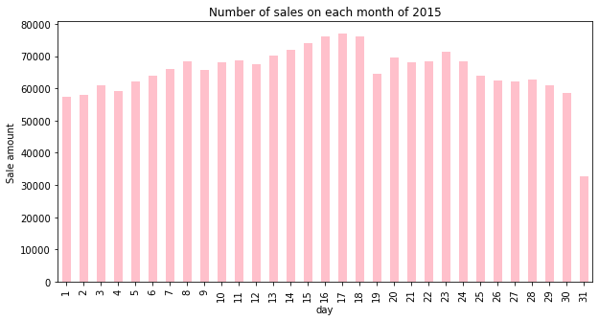

**Number of sales each day of 2016:**

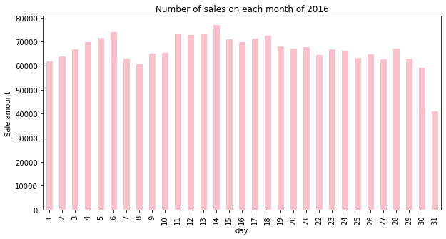

**Models sorted by the number of their sales**

